THE UNIVERSITY OF AZAD JAMMU & KASHMIR
DEPARTMENT OF SOFTWARE ENGINEERING

Student Name | Syed Muhammad Hassan Gillani | 
Roll Number | 2024-SE-42
Course Name | Software Construction & Development
Course Code | SE-3101
Session | 2024-2028 (BS SE - 5th Sem)
Department Name | Department of Software Engineering
Task / Assignment No. | Lab Task #02
Instructor Name | Engr. Dr Asma Javed
Submission Date | October 25, 2026
Topic / Title | Food Panda Activity Diagram, Toaster Diagram, Elevator/Lift Machine Diagram

SOFTWARE CONSTRUCTION & DEVELOPMENT (LAB)
LAB TASK 2: DIAGRAM ANALYSIS & EXPLANATION
- FoodPanda Application Activity Diagram (Swimlane)
The FoodPanda application is a multi-sided online food ordering and delivery ecosystem connecting four key actors: Customers, the Central Platform System, Partner Restaurants, and Delivery Riders. To accurately model this concurrent workflow, a UML Activity Diagram with four distinct swimlanes is utilized.
1.1 Swimlane Actor Breakdown & Responsibilities
- Customer Swimlane: Initiates the session by launching the application, browsing restaurant catalogs and menus, applying filters (rating, delivery time, dietary), customizing items, managing cart contents, confirming the delivery address, selecting payment methods (Online vs. Cash on Delivery), placing orders, tracking live rider GPS telemetry, receiving the order, and providing ratings/reviews.
- System / Platform Swimlane: Acts as the central backend orchestrator. It manages user authentication, location services, real-time menu availability, ETA calculations, payment gateway processing, automated restaurant dispatching, rider proximity matching, and order status updates.
- Restaurant Partner Swimlane: Receives incoming order alerts, verifies kitchen inventory and operational bandwidth, accepts or rejects orders, updates preparation timestamps (e.g., 'Preparing', 'Ready for Pickup'), and hands over sealed packages to the assigned delivery rider.
- Delivery Rider Swimlane: Receives dispatch notifications, accepts delivery tasks, navigates to the restaurant via GPS, picks up the order, verifies order details, navigates to the customer delivery address, hands over food, and confirms successful delivery completion.
1.2 Detailed Process Workflow & Decision Nodes
The workflow proceeds through structured phases incorporating conditional branches:
Phase 1 - Discovery & Cart Management: User opens app, browses menus, customizes items, and adds them to the shopping cart before proceeding to checkout.
Phase 2 - Payment & Verification: System verifies address and calculates ETA. Customer selects payment method. If online payment is chosen, the payment gateway processes the transaction. Successful payments generate order confirmation; failed payments trigger a retry prompt.
Phase 3 - Kitchen Processing & Dispatch: Order is broadcast to the restaurant. If rejected, the system initiates an instant refund and notifies the customer. If accepted, preparation time is set, and nearby delivery riders receive a dispatch request.
Phase 4 - Fulfillment & Rating: Rider accepts dispatch, travels to the restaurant, picks up the order, delivers it to the customer, and the system prompts for a customer rating.
SWIMLANE COLOR CODING PATTERN
Visual Design & Color Pattern:
• Customer Lane (Teal #008080): User-facing UI events.
• System Lane (Navy #182B49): Backend processing and orchestration.
• Restaurant Lane (Amber / Gold): Kitchen operations and prep milestones.
• Rider Lane (Coral / Orange): Transit, GPS navigation, and physical handover.

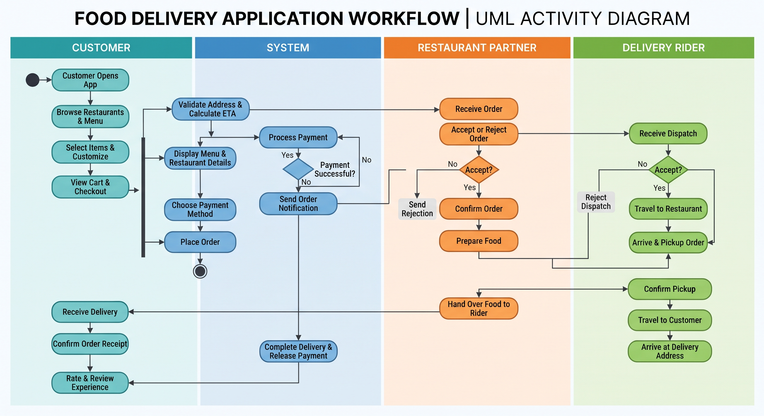
- Toaster State Diagram
A standard household electric toaster operates through a precise state machine governing mechanical carriage lever engagement, heating element activation, timer control, and thermal safety release. Below is the detailed state diagram analysis including internal activities, triggered events, and triggerless (autonomous) transitions.
2.1 States and Internal Activities
1. Idle (Off / Standby) State
The toaster is plugged in with the carriage lever in the up position and heating elements unpowered. Internal activities include monitoring electrical continuity and maintaining the mechanical latch unlatched.
2. Bread Loaded (Ready) State
Bread slices are inserted into slots, resting on the wire carriage. Internal activities include optical/mechanical bread presence detection and browning dial level scanning (1 to 5).
3. Toasting (Active Heating) State
Carriage lever depressed, mechanical latch engaged, internal circuit closed, nichrome wire heating elements glowing red, and thermal timer counting down. Internal activities include radiant heat generation, timer countdown, and ambient chassis temperature monitoring.
4. Completed / Popped-Up State
Timer expired or cancel button pressed, releasing the magnetic/mechanical latch, causing spring tension to push carriage upward. Internal activities include power cut-off to heating elements, mechanical release, and optional audio buzzer activation.
2.2 Event & Action Classification (Triggered vs. Triggerless)
State transitions in the toaster are governed by explicit external events and internal autonomous conditions:
Event / Action Name | Type | Description & Transition Behavior
Insert Bread | Triggered Event | User places bread into slots. Transitions toaster from Idle to Bread Loaded.
Push Down Lever | Triggered Event | User depresses carriage lever. Transitions from Bread Loaded to Toasting and engages latch.
Timer Expiry (Timeout) | Triggerless Event | Internal bimetallic timer reaches set duration automatically. Triggers latch release into Completed state.
Press Cancel Button | Triggered Event | User manually presses CANCEL button during Toasting, instantly forcing transition to Completed.
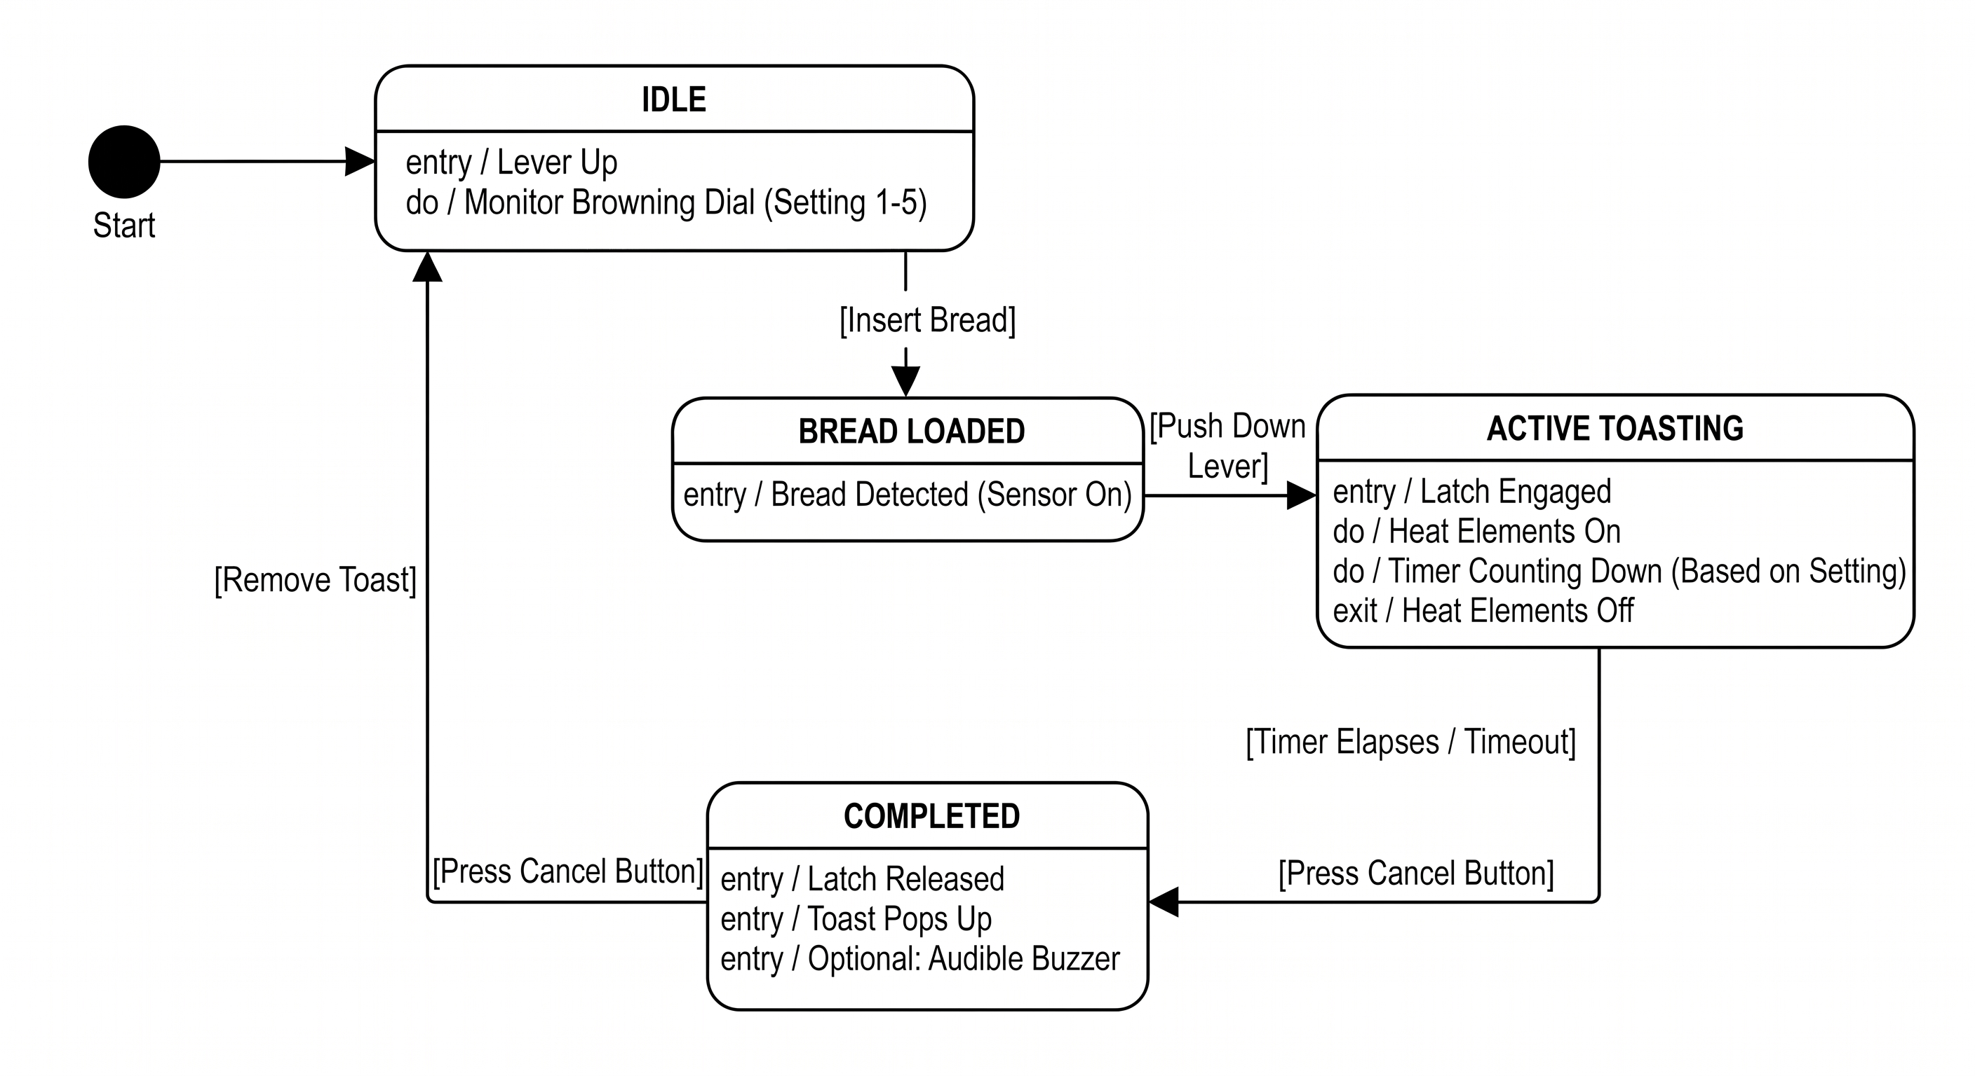
- Elevator / Lift State Machine Diagram
An elevator (lift) control system is a safety-critical real-time embedded state machine. It manages continuous motor actuation, door interlocks, floor sensors, weight overloads, emergency brakes, and passenger call queue arbitration.
3.1 Core Elevator States
1. Idle / Standby State: Stationary at a specific floor with doors closed, awaiting external hall calls or internal destination commands.
2. Door Opening State: Motor activates door operator mechanism, retracting doors for passenger boarding/exiting.
3. Doors Open State: Doors remain fully open. A dwell timer (3-5s) is active, monitored by light curtains/infrared sensors.
4. Door Closing State: Doors actively close. If an obstruction is detected by photocells, the state immediately reverts to Door Opening.
5. Moving State: Brakes disengaged, hoist motor runs at rated speed, and magnetic floor sensors track vertical transit.
6. Leveling / Stopping State: Precision floor alignment adjustments ensure flush landing with the building floor slab.
7. Emergency / Fault State: Triggered by power failure, overspeed governor, seismic sensor, or weight overload. Applies mechanical emergency brakes and triggers alarm.
3.2 State Machine Transition Matrix & Logic
The state machine transitions are governed by sensory inputs, safety interlocks, and control algorithms:
Current State | Trigger / Event | Next State & Action
Idle | Call registered at current floor or another floor | Transitions to Door Opening (if at floor) or Moving (if distant).
Doors Open | Dwell Timer Expiry OR Door Close Button pressed | Transitions to Door Closing state.
Door Closing | Obstruction detected by light curtain / safety edge | Triggerless/Triggered interrupt -> Transitions back to Door Opening.
Moving | Car reaches requested floor & magnetic sensor triggered | Transitions to Leveling / Stopping state.
Leveling / Stop | Car flush with floor slab & door lock engaged | Transitions to Door Opening state.
Any State | Weight Overload Sensor Tripped OR Safety Circuit Broken | Transitions to Emergency / Fault State immediately.

CRITICAL ENGINEERING CONSTRAINT
Safety Interlock Protocol:
In elevator design (ASME A17.1 compliance), the moving state CANNOT be entered unless the door closed and locked electrical interlock circuit is fully closed. Similarly, door opening is strictly inhibited unless the car is within the leveling zone.

